

East midlands company

SALES SUMMARY, FORECASTING & OPERATIONS OPTIMIZATION – AN ANALYSIS



Student ID : P2617280

Name : Bhagyalakshmi Gadagoju

Course : I20071-17_2021 – M.Sc. Data Analytics

Module : IMAT5264 – Business Intelligence & Application Development

Deadline Date : 26-May-2021

Module Tutor : Caroline.khene@dmu.ac.uk

Table of Contents

Introduction 2

Forecasting 2

Understanding Business Forecasting 2

Forecasting Methods: 2

Assumptions of Forecasting 2

Characteristics of a Good Forecast 3

Forecasting in East Midlands Company(EMC) 3

Limitations/Challenges with Forecasting 3

Forecasting Techniques Success Evaluation 4

Forecasting for different EMC products: 5

**EMC Products - Forecasting Patterns** 5

**EMC Products – Year 4 Forecast** 6

**Product A: Chocolate Bar** 6

Step 1: Regression Model for Product A (Chocolate Bar) 6

Step 2: Running Regression Model for Product A (Chocolate Bar) 6

Step 3: Regression Equation - for Product A (Chocolate Bar) Data 6

Step 4: Product A (Chocolate Bar) – Year 4 Forecasts 6

Step 5: Product A (Chocolate Bar) – Year 4 Forecast – Timeseries Plot & Inference 7

Step 6: Product A (Chocolate Bar) – Forecast Accuracy & Inference 7

**Product B: Children’s Treat** 7

Step 1: Regression Model for Product B (Children’s Treat) 8

Step 2: Running Regression Model for Product B (Children’s Treat) 8

Step 3: Regression Equation - for Product B (Children’s Treat) Data 8

Step 4 Product B (Children’s Treat) – Year 4 Forecasts 8

Step 5: Product B (Children’s Treat) – Year 4 Forecast – Timeseries Plot & Inference 9

Step 6: Product B (Children’s Treat) – Forecast Accuracy & Inference 9

**Product C: Adult Mint Bar** 9

Step 1: Regression Model for Product C (Adult Mint Bar) 9

Step 2: Running Regression Model for Product C (Adult Mint bar) 10

Step 3: Regression Equation - for Product C (Adult Mint bar) Data 10

Step 4 Product C (Adult Mint bar) – Year 4 Forecasts 10

Step 5: Product C (Adult Mint bar) – Year 4 Forecast – Timeseries Plot & Inference 10

Step 6: Product C (Adult Mint bar) – Forecast Accuracy & Inference 11

Linear Programming/Linear Optimisation 12

Overview of Optimisation and its benefits in EMC 12

Optimisation Mathematical Modelling in EMC (for Production/Manufacturing) 13

Linear Programming Model for Problem Case 1 (Production) 13

Linear Programming Model for Problem Case 2 (Staff Allocation) 14

Business Intelligence Systems: 16

EMC Entity Details 16

SAS InfoMap 16

SAS Web Reports 18

SAS Integrated Development Portal (IDP) 19

System Evaluation 20

Limitations of the Software and the Solution 20

Compliance (legal), Ethics, and Privacy Issues in Business Intelligence 21

References 23

Appendix 24

## Forecasting for different EMC products:

### **EMC Products - Forecasting Patterns**

Analysis of EMC’s 3 Products Chocolate Bar (Product A), Children's Treat (Product B), and Adult Mint Bar(Product C) data for 3 years covering 4 quarters each year indicates the following forecasting pattern for each of the product as below

|  |  |  |  |
| --- | --- | --- | --- |
| **Product** | **Product Time Series Data**  **for 3 years & 4 seasons** | **Time Series Plot on Product Sales** | **Forecasting Pattern** |
| Chocolate Bar  (Product A) |  |  | **TREND & SEASONAL PATTERN** ( Seasonality with Trend)  **Trend** – An increasing trend is evident over the 3 years.  **Seasonal –**  Every ‘Spring’ Season each year -lowest sales  Every ‘Autumn’ Season each year – highest sales |
|  |  |  |  |
| Children's Treat (Product B) |  |  | **SEASONAL PATTERN** (Seasonality without Trend)  **Seasonal** -  A systematic pattern exists for every season within each year:  **Winter**: Moderate Sales  **Spring** & **Summer** Quarter: Highest Sales  **Autumn**: Lowest Sales |
| Adult Mint Bar  (Product C) |  |  | **TIME SERIES WITH A LINEAR TREND**  Sales are progressively in increasing trend quarter on quarter |

### **EMC Products – Year 4 Forecast**

### **Product A: Chocolate Bar**

Considering the data for Product A(Chocolate Bar), the time series plot indicates that there is both Linear Trend and Seasonal pattern. Hence the Forecasting Model to be used for Product A (Chocolate Bar) is **Regression Analysis (Forecasting Seasonality with Trends)**

*Step 1: Regression Model for Product A (Chocolate Bar)*

|  |  |
| --- | --- |
| **Product Time Series Data with Dummy Variables for 3 years & 4 seasons** | **General Linear Equation for Product A forecasting** |
|  | Linear Equation is obtained by constructing a Regression Model with Dummy Season Variables to account for the Seasonal effects in the data       * Ssn1 = 1 if Season= ”Winter”, 0 otherwise * Ssn2 = 1 if Season= ” Spring”, 0 otherwise * Ssn3 = 1 if Season= ” Summer”, 0 otherwise * t= time period |

*Step 2: Running Regression Model for Product A (Chocolate Bar)*

The summary output of the Regression Model executed for Product A data using Data Analysis Tool in Excel is as below

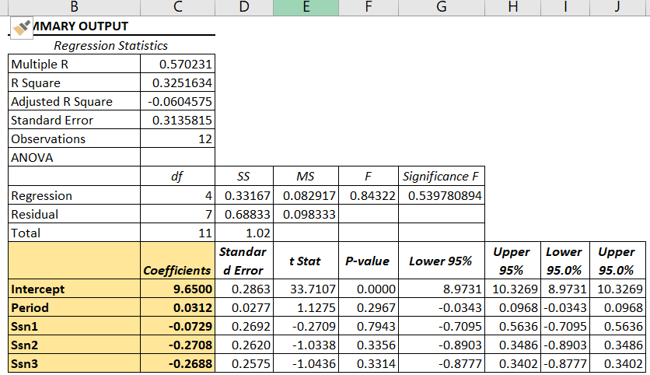

*Step 3: Regression Equation - for Product A (Chocolate Bar) Data*

Substitution of values from the table above for the variables and the intercept, the regression equation obtained for Product A (Chocolate Bar) is as follows



*Step 4: Product A (Chocolate Bar) – Year 4 Forecasts*

1. Based on the Regression model developed above, the quarterly forecasts for Year 4 can be computed as below for all the 4 Seasons.

Forecasting for sales of 4th Year and periods 13 (Winter), 14(Spring), 15(Summer),16(Autumn)

1. Winter :
2. Spring :
3. Summer :
4. Autumn :
5. Considering the Sales in ‘000s, the Unit Sales of Product A (Chocolate Bar) for the Fourth year and for different seasons is as follows.
6. Winter = 9982 Units, Spring = 9816 Units, Summer= 9984 Units Autumn= 10149 Units

*Step 5: Product A (Chocolate Bar) – Year 4 Forecast – Timeseries Plot & Inference*

|  |  |
| --- | --- |
| Time series Plot for Prod A with Year 4 Forecast | Forecast Inference |
| Product A data still follows Seasonal & Trend Pattern | Four Regression Equations used for calculating the forecast for Year 4, can be rewritten as follows  Winter :  Spring :  Summer :  Autumn :  Slope of the Trendline for each season forecast is 0.312 indicating a consistent growth in Sales(Considering the Sales in ‘000s) of about 31 Products of Product A (Chocolate Bars) per Season. |

*Step 6: Product A (Chocolate Bar) – Forecast Accuracy & Inference*

The table below provides the computational values of the errors in forecasting.

|  |  |  |
| --- | --- | --- |
| **Forecasting Accuracy Measuring Method** | **Formula** | **Value** |
| Mean Forecast Error(MFE) |  | **0.0003** |
| Mean Absolute Error(MAE) |  | **0.175** |
| Mean Squared Error(MSE) |  | **0.0574** |
| Mean Absolute Percentage Error (MAPE) |  | **1.7783%** |

|  |  |  |  |
| --- | --- | --- | --- |
| k | 0 | As NO previous values are used for Forecasting |  |
| n | 12 | Count of Entries in the Data( 12 records) |  |

The MAPE (percentage error) in forecasting is only around **1.7783%** indicating this forecast is highly accurate and reliable. The other forecast accuracy measures like Mean Average Error and Mean Absolute Error are also relatively very lesser again ensuring forecasting accuracy.

### **Product B: Children’s Treat**

Considering the data for Product B(Children’s Treat), the time series plot indicates that is a Seasonal pattern. Hence the Forecasting Model to be used for Product B(Children's Treat is **Regression Analysis (Forecasting Seasonal Patterns)**

*Step 1: Regression Model for Product B (Children’s Treat)*

|  |  |
| --- | --- |
| **Product B Time Series Data with Dummy Variables for 3 years & 4 seasons** | **General Linear Equation for Product B forecasting** |
|  | Linear Equation is obtained by constructing a Regression Model with Dummy Season Variables to account for the Seasonal effects in the data       * Ssn1 = 1 if Season= ”Winter”, 0 otherwise * Ssn2 = 1 if Season= ” Spring”, 0 otherwise * Ssn3 = 1 if Season= ” Summer”, 0 otherwise * t= time period |

*Step 2: Running Regression Model for Product B (Children’s Treat)*

The summary output of the Regression Model executed for Product B data using Data Analysis Tool in Excel is as below

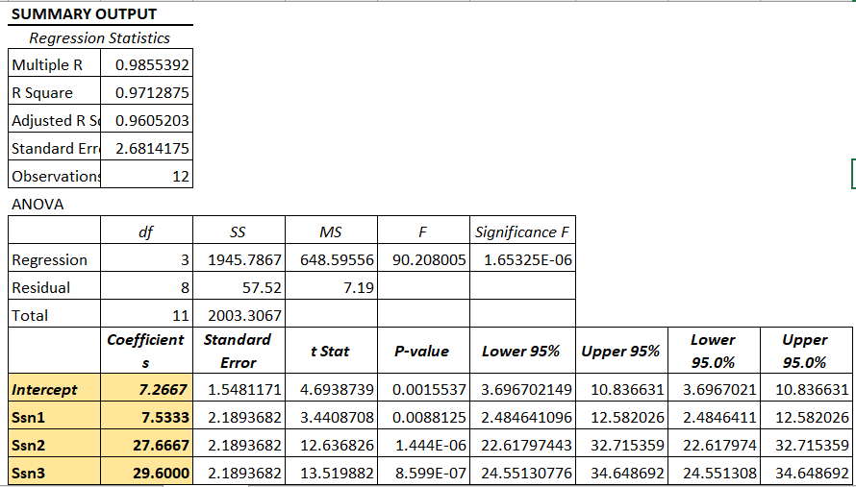

*Step 3: Regression Equation - for Product B (Children’s Treat) Data*

Substitution of values from the table above for the variables and the intercept, the regression equation obtained for Product B (Children’s Treat) is as follows



*Step 4 Product B (Children’s Treat) – Year 4 Forecasts*

1. Based on the Regression model developed above, the quarterly forecasts for Year 4 can be computed as below for all the 4 Seasons.

Forecasting for sales of 4th Year and time periods 13 (Winter), 14(Spring), 15(Summer),16(Autumn)

1. Winter :
2. Spring :
3. Summer :
4. Autumn :
5. Considering the Sales in ‘000s, the Unit Sales of Product B (Children’s Treat) for the Fourth year and for different seasons is as follows.
6. Winter = 14800 Units, Spring = 34930 Units, Summer= 36867 Units Autumn= 7266 Units

*Step 5: Product B (Children’s Treat) – Year 4 Forecast – Timeseries Plot & Inference*

|  |  |
| --- | --- |
| **Time series Plot for Prod B with Year 4 Forecast** | **Forecast Inference** |
| Product B data still follows Seasonal Pattern | Obtaining the forecast of Product B, by considering the Average of Products sold in each season, the same forecast results are obtained as using regression analysis which confirms the Forecast Numbers for each season for Year 4.     1. Considering the Sales in ‘000s, the Unit Sales of Product A (Chocolate Bar) for the Fourth year and different seasons is as follows. 2. Winter = 14800 Units, Spring = 34930 Units, 3. Summer= 36867 Units Autumn= 7266 Units |

*Step 6: Product B (Children’s Treat) – Forecast Accuracy & Inference*

The table below provides the computational values of the errors in forecasting.

|  |  |  |
| --- | --- | --- |
| **Forecasting Accuracy Measuring Method** | **Formula** | **Value** |
| Mean Forecast Error(MFE) |  | **0** |
| Mean Absolute Error(MAE) |  | **1.4778** |
| Mean Squared Error(MSE) |  | **4.7933** |
| Mean Absolute Percentage Error (MAPE) |  | **5.3725** |

|  |  |  |  |
| --- | --- | --- | --- |
| k | 0 | As NO previous values are used for Forecasting |  |
| n | 12 | Count of Entries in the Data( 12 records) |  |

The MAPE (percentage error) in forecasting is only around **5.3525%** indicating the forecast is off by 5.3% and hence can be considered reliable. The other forecast accuracy measures like Mean Average Error and Mean Absolute Error are also relatively very lesser again ensuring forecasting accuracy.

### **Product C: Adult Mint Bar**

The data for Product C(Adult Mint Bar), infers the pattern to be **TIME SERIES WITH A LINEAR TREND**. Hence the Forecasting Model to be used for Product C (Adult Mint Bar) is **Regression Analysis (Simple Linear Regression).**

*Step 1: Regression Model for Product C (Adult Mint Bar)*

|  |  |
| --- | --- |
| **Product C** **Time Series Data 3 years & 4 seasons** | **General Simple Linear Equation for Product C forecasting** |
|  | Linear Equation is obtained by constructing a Regression Model for the Trendline as below      t = time period   1. b0 =Intercept, b1 =Slope of the linear trendline |

*Step 2: Running Regression Model for Product C (Adult Mint bar)*

The summary output of the Regression Model executed for Product C data using Data Analysis Tool in Excel is as below

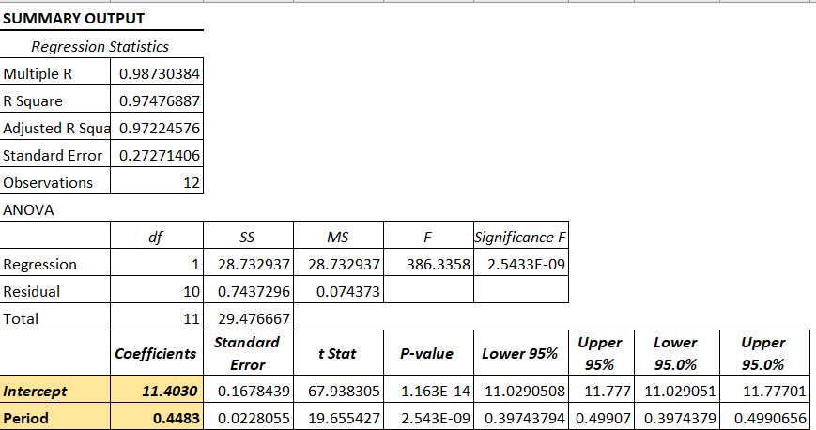

*Step 3: Regression Equation - for Product C (Adult Mint bar) Data*

Substitution of values from the table above for the variables and the intercept, the simple linear regression equation obtained for Product C (Adult Mint Bar) is as follows



*Step 4 Product C (Adult Mint bar) – Year 4 Forecasts*

1. Based on the Regression model developed above, the quarterly forecasts for Year 4 can be computed as below for all the 4 Seasons.

Forecasting for sales of 4th Year and time periods 13 (Winter), 14(Spring), 15(Summer),16(Autumn)

1. Winter :
2. Spring :
3. Summer :
4. Autumn :
5. Considering the Sales in ‘000s, the Unit Sales of Product C (Adult Mint Bar ) for the Fourth year and different seasons is as follows.
6. Winter = **17230** Units, Spring = **17679** Units, Summer= **18127** Units Autumn= **18575** Units

*Step 5: Product C (Adult Mint bar) – Year 4 Forecast – Timeseries Plot & Inference*

|  |  |
| --- | --- |
| **Time series Plot for Prod C with Year 4 Forecast** | **Forecast Inference** |
| Product C data still follows Simple Linear Trend | Product C forecast indicates Sales growth is an increasing trend in Year 4 for each of the Seasons.  Considering the Sales in ‘000s, the Sales of Product C (Adult Mint Bar) for the Fourth year are as follows.   1. Winter = **17230** Units, Spring = **17679** Units, 2. Summer= **18127** Units Autumn= **18575** Units |

*Step 6: Product C (Adult Mint bar) – Forecast Accuracy & Inference*

The table below provides the computational values of the errors in forecasting.

|  |  |  |
| --- | --- | --- |
| **Forecasting Accuracy Measuring Method** | **Formula** | **Value** |
| Mean Forecast Error(MFE) |  | **-0.0003** |
| Mean Absolute Error(MAE) |  | **0.2236** |
| Mean Squared Error(MSE) |  | **0.062** |
| Mean Absolute Percentage Error (MAPE) |  | **1.6513** |

|  |  |  |  |
| --- | --- | --- | --- |
| k | 0 | As NO previous values are used for Forecasting |  |
| n | 12 | Count of Entries in the Data( 12 records) |  |

The MAPE (percentage error) in forecasting is only around **1.6513%** again indicating this forecast is fully accurate and reliable. The other forecast accuracy measures like Mean Average Error and Mean Absolute Error are also relatively very lesser again ensuring forecasting accuracy

---------------------------------------------------------------------------------------------------------------------------------------

Linear Programming/Linear Optimisation

### Linear Programming Model for Problem Case 1 (Production)

**Problem Statement:** To understand how many Production Units of Standard Popcorn and Deluxe popcorn to be produced to maximize profit based on the following requirements to produce

Standard Vs Deluxe Popcorn

|  |  |
| --- | --- |
| Requirements |  |
| Constraints | * Sugar Supply - Limited to 40,000Kg/Week * Coloring capacity is that EMC only has 48 litres of colouring |

**Linear Programming Model :**

A standard Linear Programming model for EMC Company Production can be developed as below.

The table below list the variables and the values/equations as appropriate.

|  |  |
| --- | --- |
| **Decision Variables** | X1 = Kg of Standard Popcorn to be produced  X2 = Kg of Deluxe Popcorn to be produced |
| **Result Variable** | Total Profit = Z |
| **Objective is to Maximize Profit/Sales** | **Z = 50X1 + 80X2** |
| **Uncontrollable Variables (Constraints)** | **Sugar Constraint :** 300X1+400X2 <= 40000000 (in gms)  **Coloring Constraint** : 8X1+15X2 <= 48000 (in millilitres)  **Production Requirement** : X1 >=1000 (in Kgs) |
| **Mathematical Modelling** |  |

Business Intelligence Systems:

A Business Intelligence system for different Sales Group Teams in EMC(Retail, Wholesale and Grocery) with the following features was constructed using the SAS Business Intelligence Solution Stack – SAS Info Maps, SAS Web Reports and SAS Integrated Development Portal (IDP).

* Sales group specific IDP Pages to
  + Tabular picture of the consolidated Sales Summary yearly (for the selected year) for each Product Group
  + Graphical picture of the consolidated Sales Summary for different Customers (for chosen Product Category and Year)

### EMC Entity Details

A brief repository of EMC Entities (Tables) storing products and sales to be used for BI system construction

|  |  |  |
| --- | --- | --- |
| Table Name | Entity Details | Master/ Transaction |
| Candy_Customers | This is the Master Table which contains the list of EMC Customers along with the Region and Types they belong to. | Master/ Transaction |
| Candy_Products | This is the Master Table repository of different products and the associated product details like Product Category, Subcategory, price etc. | Master (Reference) |
| Candy_Time_Periods | Master Table storing metadata about any given date like Year, Fiscal Year, Quarter, Fiscal quarter if that date falls on a holiday, week details etc. | Master (Reference) |
| Candy_Sales_History | Transactional Table maintaining history of sales to different customers. Information stored covers Order Details, products and no. of units purchased and the date of Sales etc. | Transactional |
| Candy_Sales_Summary | Contains Sales information as stored in Sales History with additional details on the commercials of the sales and the other metadata of the Date and the Customers | Transactional |

Refer to APPENDIX for various Entity Details.

### SAS InfoMap

SAS Information maps and filters are a critical component in the SAS Business Intelligence packages which are business data about physical data providing easy access to enterprise data to the Business Users. The creation of SAS InfoMap is through Information Map Studio which is a Graphical User Interface to create, edit and view Information maps.

The main structure of the EMC relational information map created is as below.

|  |  |
| --- | --- |
| **EMC Infomap – EMC** | **Description About EMC Infomap** |
|  | Infomap is created with Base Table as **Candy_Sales_History**. Information used from this table is Customer, Date, Units, ProdId.  Necessary **JOINS** between Candy_Sales_history and other tables are established to retrieve the relevant information from the other Master Tables and Transactional tables.   1. Customer Details (Name, Type, Region) from **Candy_Customer Table** based on CustId 2. Product Information(Category, Subcategory) from **Candy_products** table 3. Sales Details (Sales Amount) from **Candy_Sales_history** 4. Time period detail (Fiscal Year and Fiscal Quarter) from **Candy_Time_periods** 5. Various **Filters** to generate reports for 3 sales(Retail/Grocery/Wholesale) groups    * Customer Types      + **Retail Filter**: Used to Filter only the RETAILER Type Customers      + **Grocery Filter**: Used to Filter only the GROCERY Type Customers      + **Wholesale Filter**: Used to Filter only the WHOLESALE Type Customers    * **Product Category Filter**: Filter to chose product category for Sales Summary Generation.    * **Fiscal Year Filter**: To choose a Fiscal Year for which the Sales summary has to be generated   Considering the best practices for scalability of the Reporting solution to accommodate additional details in the Sales Summary report (which are currently not as part of CANDY_SALES_SUMMARY table (ex: like Product Retail Price, Royalty Charges), the Infomap designed considered the CANDY_SUMMARY_HISTORY as the Base table with relevant joins to the other tables like Customers, Sales Summary etc and not considered to use only CANDY_SALES_SUMMARY. |
| Entity Relation Diagram | The Entity Relationship amongst the various Tables to generate a report on Sales History for various customer groups and selected Product Categories and Fiscal Year/Quarter is as below. The various  Integrity constraints(Primary key and foreign key relationships)set between the tables can be referred to in Infomap. |
| Folder Location in SAS Information Map Studio |  |

### SAS Web Reports

SAS Web Report Studio - a business intelligence component part of the SAS Intelligence Platform that allows end-users to view, create, and share web-based reports. Sales Summary for 3 different EMC Sales group(Retail, Grocery & Wholesale) is presented in 2 forms (Tabular & Graphical View) for dual representation of the same data for Number analysis and pictorial view.

Screen layouts of the reports are as below

Fig a: **Screenshot of Tabular WebReport**: Sales Summary for the Fiscal Year 1999 for Retail Sales Group

This report provides a Sales Summary for different Product Categories alongside Product subcategories and products for the Chosen Year in different quarters.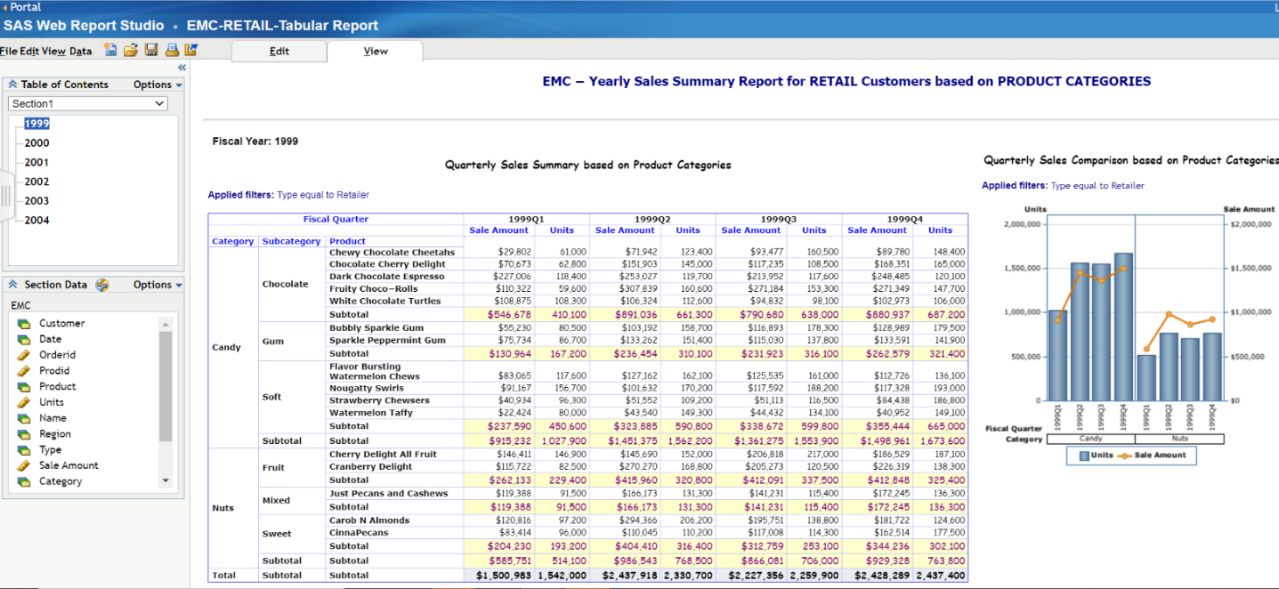

Fig b: **Screenshot of Graphical WebReport**: Sales Summary for the Fiscal Year 1999 for Retail Sales for Product Category CANDY based on Customers. These reports help in comparative analysis of Sales Amount Vs Units sold for different customers for the selected year(Ex:1999) and category(CANDY) for EMC - Retail sales group.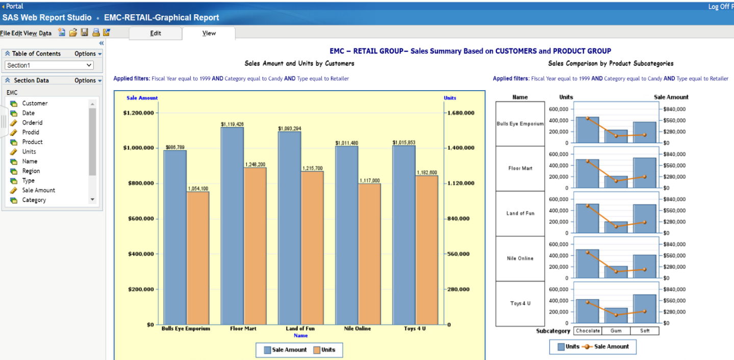

Reports to be assessed in SAS Web reports:

|  |  |
| --- | --- |
| RETAIL Sales Group – Tabular Report | EMC-RETAIL-Tabular-Report |
| RETAIL Sales Group – Graphical Report | EMC- RETAIL-Graphical-Report |
| GROCERY Sales Group – Tabular Report | EMC-GROCERY-Tabular-Report |
| GROCERY Sales Group – Graphical Report | EMC- GROCERY -Graphical-Report |
| WHOLESALE Sales Group – Tabular Report | EMC-WHOLESALE-Tabular-Report |
| WHOLESALE Sales Group – Graphical Report | EMC- WHOLESALE -Graphical-Report |

### SAS Integrated Development Portal (IDP)

The SAS Information Delivery Portal (IDP) is a web application that allows users to present reports, graphs, weblinks, document links in a simple User Interface.

The IDP Screen layout for EMC Candy considering individual TAB for each of the Sales Group is as below. Each of the Sales Group Tab has portlets reference to the individual SAS web reports (both Tabular & Graphical Contents)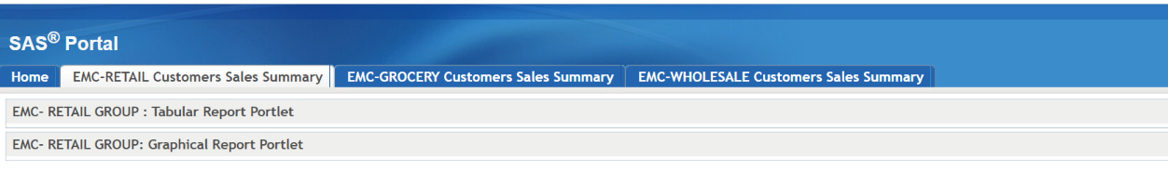 The Detailed view of IDP Page post expansion of portlet details